●Non-Spill: negative case,or majority class.

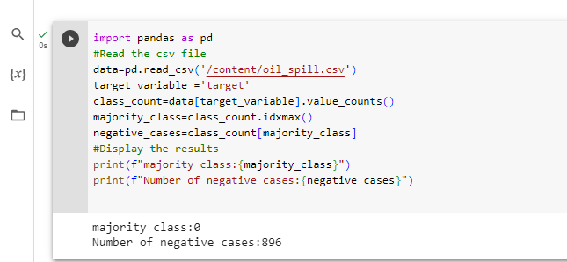

●Oil Spill: positive case, or minority class. There are a total of 50 Columns in the Dataset, the out put column is named as target.

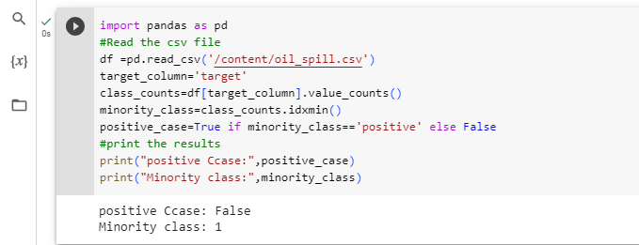

●Download the Oil Spill Dataset and perform Data cleaning and Data Pre-Processing if Necessary.

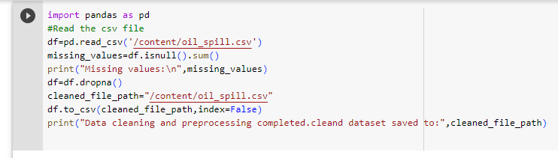

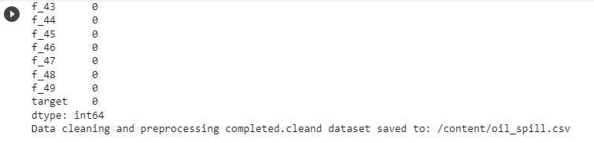

●Use the various methods such as Handling null values, One

Hot Encoding, Imputation and Scaling of Data Pre-Processing where necessary.

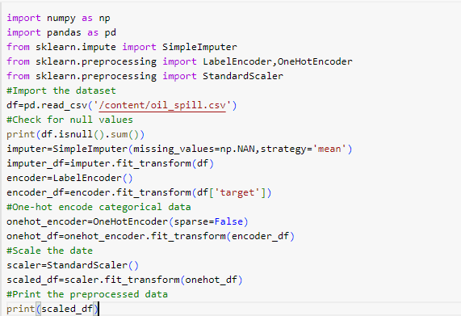

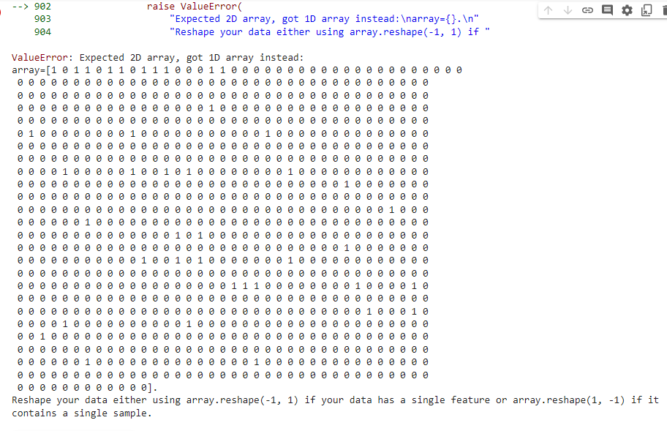

●Derive some insights from the dataset.

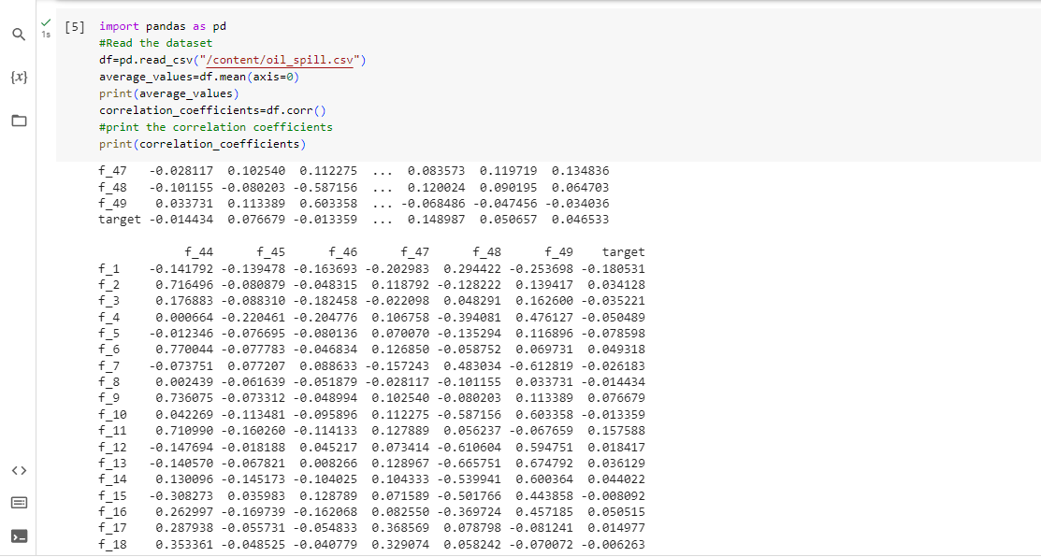

.●Apply various Machine Learning techniques to predict the out put in target column, make use of Bagging and Ensemble as required and find the best model bye valuating the model using Model evaluation techniques.

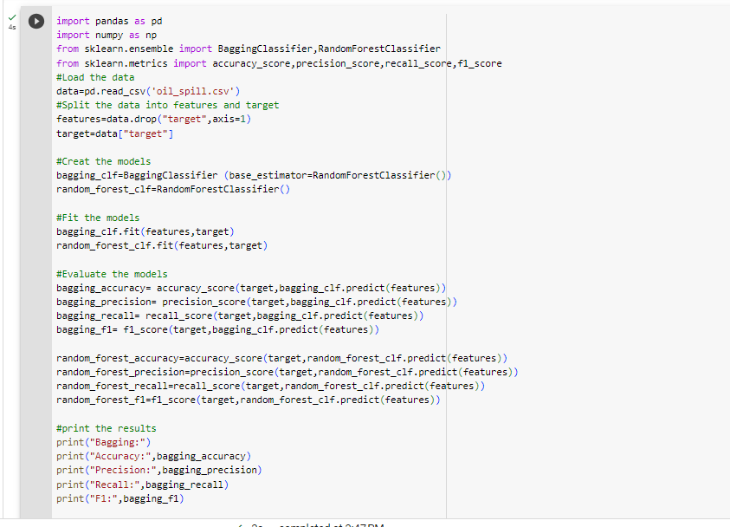

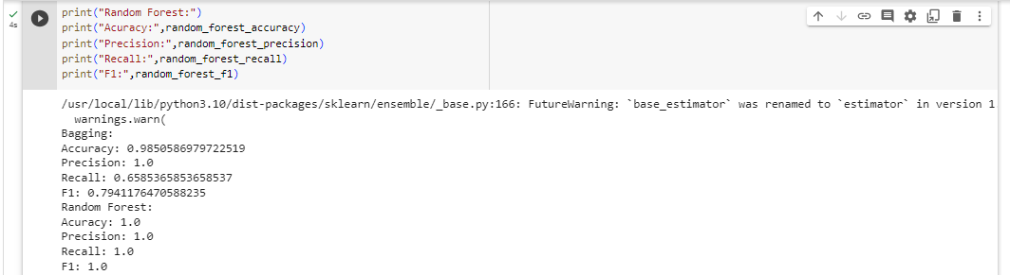

●Save the best model and Load the model.

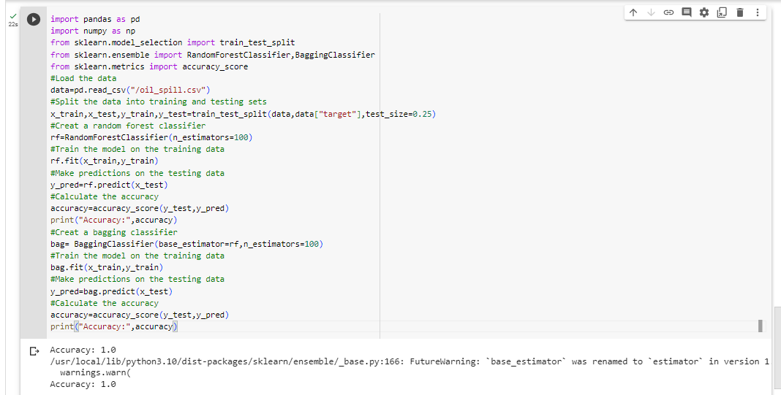

●Take the original data set and make another data set by randomly picking 20 data points from the oil spill data set and apply the saved model on the same.

